April | #Inspire! #Create! #Thrive!  http/thesewinglabs.community
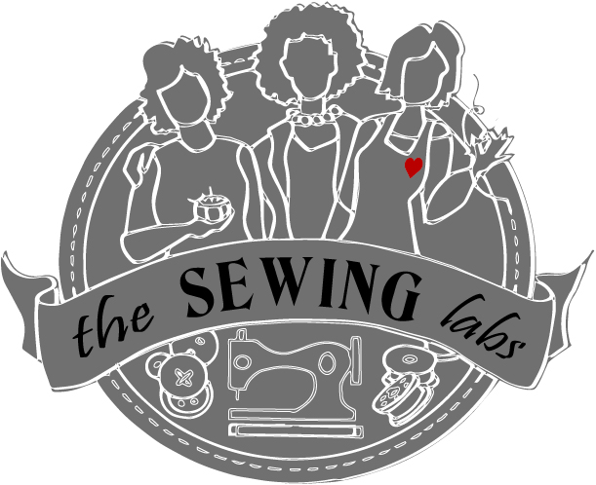  2017 | 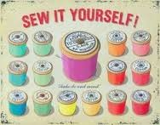
Sunday | Monday | Tuesday | Wednesday | Thursday | Friday | Saturday
 |  |  | 29 | 30 | 31 | 1
Call or go on line to register for classes – http//thesewinglabs.community or call 816-286-3097  Materials are included in most class fees  All classes prefer advance registration |  |  |  | Community  Mending  Day 11-7
2 | 3 | 4 | 5 | 6 | 7 | 8
 |  |  | Volunteer Committee – Quilting 2-4 pm | Closures 10-12  Open Sew 1-4  6-8 Testing for Certification Phase 1
9 | 10 | 11 | 12 | 13 | 14 | 15
Palm Sunday |  |  | Volunteer Committee – Quilting 2-4 pm | NO  CLASSES | Just SEW-cial  11-7
16 | 17 | 18 | 19 | 20 | 21 | 22
Easter Sunday |  |  |  | Textiles 10-12  Open Sew 1-4  6-8 Testing for Certification Phase 1 |  | Earth Day
23 | 24 | 25 | 26 | 27 | 28 | 29
Unity of Independence  Workday |  |  | Volunteer Committee – Quilting 2-4 pm | 10 – 12 Testing for Certification Phase 1  Sewing Machine Basics 2-4  Patterns 6-8 |  | Prayer Flags  9-12
30 | 1  The Sewing Labs  is located @  803 E 27th Street  KCMO 64108 | 2 | 3 | 4  10 – 12 Testing for Certification Phase 1  Tool Time 2 – 4  Pattern 6-8 | 5 | 6
See back for Class descriptions and pricing For Registration or more information - https://thesewinglab.community or email – operations@thesewinglabs.community or call/text – Linnca Stevens – Program Manager 816–286-3097

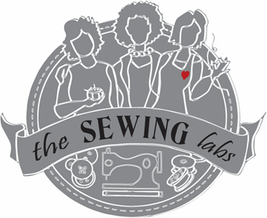
April 2017 Activities & Classes

Thank you for your community involvement!
We accept donations; fabric, sewing machines, notions etc. & funding is always welcome
** Limited Scholarships are available to cover some fees – Ask for scholarship application **

Open Sew – Bring your sewing machine or rent one of ours ($10 for 2 hours) Use our tools and stash to create your project. This is an open format with no instructions but, volunteers are available to help. Use the Open Sew time to practice your skills or to work on your own personal project. Class Fee is only to cover sewing machine rental = $10 for 2 hours

Closures – Zippers, Buttons & snaps - Learn different applications and uses for closures. Zippers; centered, lapped, invisible, exposed, separating. Also, how to shorten a zipper. Buttons & buttonholes - machine buttonholes, Bond & corded buttonholes. Proper sewing of shank & flat buttons. Applying Hooks & eyes, snaps, & Velcro closures. You will create samples of many different types of these to have for future reference. All materials provided Class Fee = $20

Textiles - Getting to know your fabrics is a must to assure you get the best performance. This class covers an array of fabrics for sewing. Whether the application is for garment sewing, home decor, quilting or crafts. Learn what to consider when purchasing fabric, fiber content, finishes and designs. Participants will create a collection of sample for future reference. Class Fee = $20

Sewing Machine Basics – This class is for first time sewing machine owners or someone who needs a refresher course. Learn the features of your sewing machine, how they work and what is their purpose. Learn sewing machine maintenance and proper selection of needles & thread. Class Fee = $20

Patterns - Patterns are your blueprint to fashion. This class will teach you the tips to select a pattern and decide on the correct size for your body. We will cover body measurements & size charts. Reading the pattern envelope choosing the correct fabrics, Pattern layouts, markings. Reading the pattern guide & careful & accurate cutting. Class Fee = $20

Tool Time - This class will teach you the Tools of sewing from scissors to rotary cutters, from pins to needles, rulers, rippers & markers - Oh My! Class Fee = $20
Just “SEW”cial – This is an open format. Come to hang out at The Sewing Labs. Sew or socialize. Bring your friends - the Lab and all its tools and equipment & supplies are available for you. There is no instruction during the social hours. But, it's a great opportunity to make a project, get caught up on a project or to simply gather with others. No registration is required. Enjoy Coffee and treats for FREE!

Community Mending Day - At The Sewing Labs, one of our objectives is to support the community. Community Mending Day is just one of these days. The Sewing Lab is open for the community - our students and volunteers will be on site to do basic mending. This gives our students the practice their new skills. Hemming, Sewing on buttons,
Simple mending. We will not do alterations on Mending Day.
Hemming Pants = $15, Hem Dresses = $ 20, Sewing Buttons = $1.00/ea.,
Simple Mending – patch/ resew seam = $5.

Prayer Flags - Join us @ The Sewing Labs to create your own personal Prayer Flags. These inspirational flags are created to share positive energy into the world around us. This is a great class for your prayer group, or women friends to do together. Call to schedule a private group time. All supplies included but, you are welcome to bring your personal embellishments. Class Fee = $15
Unity of Independence - Unity of Independence has partnered with The Sewing Labs to help us to build the kits for our classes. Monthly, the group gathers together to build the kits needed for the Sewing Labs. We enjoy fellowship while supporting each other. You are welcome to join us to build the kits after the morning services. Advance registration is suggested.

Volunteer Committee Meeting – Become a partner at The Sewing Labs by joining a committee to develop & support programs. Whether you are interested in teaching or helping, your involvement is key for the success of our programs.

Testing – Upon completion of a phase of programing, students will be tested to verify completion and mastering of subject matter to earn a Certification of Achievement.

