August | #Inspire! #Create! #Thrive!  http/thesewinglabs.community
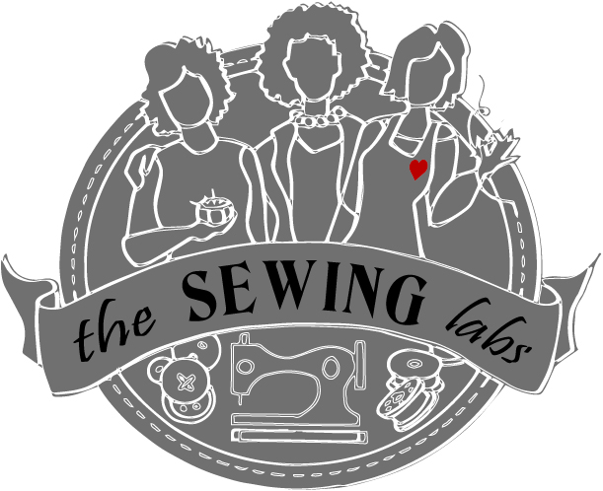  2018 | 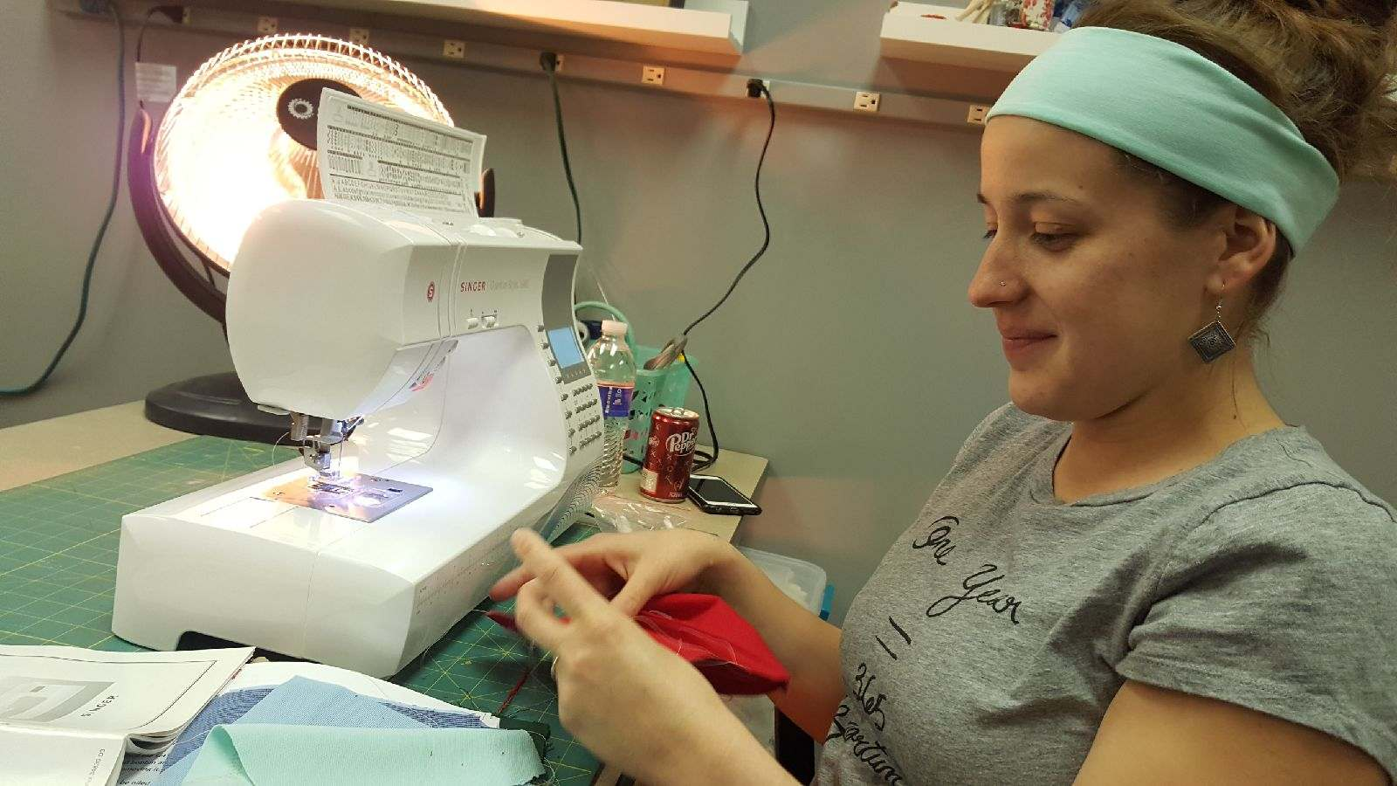
Sunday | Monday |  | Tuesday | Wednesday | Thursday | Friday | Saturday
 |  |  |  | 1 | 2 | 3 | 4
Call or go on line to register for classes – http//thesewinglabs.community  or call 816-286-3097  Materials are included in most class fees  All classes prefer advance registration |  | Makers City - OB Set Up  Community Quilt 6-8 |  | Makers City – OB Set up – NO Classes | Makers City - OB Set Up  Intro to Patterns  3 of 6, 6-8pm  Commercial 6-8pm | Makers City – OB  Set up – NO Classes
5 | 6 |  | 7 | 8 | 9 | 10 | 11
Camp Innovation  Operation Breakthrough  8/6 thru 8/10  8 - 5 |  |  | Community Quilt  6-8pm |  | Intro to Patterns  4 of 6, 6-8pm  Commercial  6-8pm |  | Walking Foot Quilting  9-11
12 | 13 |  | 14 | 15 | 16 | 17 | 18
 |  |  | Open Sew 10-12  Sew Basics 1-4  Hand Embroidery 4:30-5:30  Community Quilt  6-8pm |  | Cube Pillows 10-12  Sew Basics 1-4  Intro to Patterns  5 of 6, 6-8pm  Commercial  6-8pm | Serger Basics 10-3
19 | 20 |  | 21 | 22 | 23 | 24 | 25
 |  |  | Open Sew 10-12  Sew Basics 1-4  Quilt Committee 430-530  Community Quilt  6-8pm | Volunteer Orientation  6-8pm | Sewing Committee 10-11  Sew Basics 1-4  Intro to Patterns  6 of 6, 6-8pm  Commercial  6-8pm | Serger & Knits 10-3  Labs Work Day 1-4 | Walking Foot Quilting  9-11
26 | 27 |  | 28 | 29 | 30 | 31
 |  |  | Open Sew 10-12  Sew Basics 1-4  Hand Embroidery 4:30-5:30  Community Quilt  6-8pm |  | Infinity Scarfs  10-12  Sew Basics 1-4  Girl Night 6-10  6-8pm  Commercial  6-8pm | Call or go on line to register for classes – http//thesewinglabs.community  or call 816-286-3097  Materials are included in most class fees  All classes prefer advance registration
See back for Class descriptions and pricing For Registration or more information - https://thesewinglab.community or
email – operations@thesewinglabs.community or call/text – Linnca Stevens – Program Manager 816–286-3097

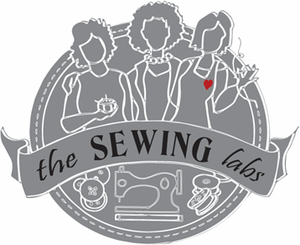
August 2018 Activities & Classes
Thank you for your community involvement!
We accept donations; fabric, sewing machines, notions etc. & funding is always welcome
** Limited sponsorships are available to cover some fees – Ask for application **

*** NEW*** Girls Night – August 30th – 6-10 pm Grabs some girlfriends or come make new ones. This is a fun night of friendship sewing! August project is Vison Journals. Make a uniquely yours Journal cover featuring; fabrics, embroidery, and more. Then stitch together to complete for your personal use or a great gift. Snacks and drinks provided no alcohol allowed). Fee $40 or 2 for $70

Open Sew – Bring your sewing machine or reserve one of ours. Use our tools and stash to create your project or bring your own fabric. This is an open format with no instructions but, volunteers are available to help. Use the Open Sew time to practice your skills or to work on your own personal project. Class Fee is FREE – but you need to reserve our machines if needed.

Hand Embroidery – Learn basic hand embroidery stitches while creating a fun sampler. Running stitch, cross stitch, French knot and more. Brenda Daily, your experienced Stitcher will guide you and share many samples of projects than can be enhanced with embroidery. A new sampler is offered each month. The class 2 hours sessions & includes all materials. Take one class or keep coming back each week to build your library of stitches. Class Fee = $5 weekly or $15 monthly

Cube Pillows – Kid Friendly - This is a great class for Children & Adults – make a fun cube pillow using 5” Charm squares. Learn to cut Charm packs & piece basic 4 patch while making a 3D cube or Ottoman for play or sitting. All Materials provided. Class Fee $20

Infinity Scarfs – Kid Friendly – Combine different fabrics & trims while making a beautiful infinity scarf. Wear it for fashion or warmth. Learn about differently lengths and fabrics choices. Materials available or bring ½ yd. or 2 fabrics + 1yd trim. Class Fee $20

Intro to Patterns– This course is for sewist wanting to earn a certification or refresh their skills. Discover the world of sewing with patterns. Course covers pattern selection, measurements & sizing. Learn to use pattern layout, cutting & marking, textile selection, interfacings and more. Complete a basic top during course. For certification, testing is required at end of course. Phase 1 is prerequisite for this class or test out. You will create samples for future reference. All materials included. 6-8 wks. Course Fee $150

Community Quilt – Join our quilting group to complete the Heart of Kansas City Quilt project. The community of makers sewed the heart blocks and now it is ready to make a completed quilt. This group will be constructing the quilt top together so that the quilt will be ready for display. Group will meet each Tuesday evening from 6-8 pm in August until the quilt top is completed FREE -

Walking Foot Quilting – Take lessons from recognized quilting artist Jane Bromberg on the art of Walking Foot Quilting you’re your home machine. Bring your latest quilt top or use our samples to explore and master this skill. This class is 2 sessions; Saturday 8/11 & 25 from 9 am – 1. (Bring a snack) Class Fee $80 for 2 sessions
Commercial Sewing –. Learn the skills to operation several types of commercial machines; straight needle, serger, cover-stitch and more. Skills building for accuracy & speed using working examples, real work-room site tours included. This course is for the person interested in securing employment in sewing. Course consists of class lectures & lab work. First 8 weeks covers the basic straight needle operation. Testing is required for certification. $250/month, $1500/6 months

Volunteer Orientation Do you want to volunteer @ TSL? do you just want to know more about it? TSL requires all its volunteers to get thru an orientation. This is a great opportunity to explore what is happening @ The Sewing Labs. Pre-registration is recommended
Committee Meeting – Become a partner at The Sewing Labs by joining a task team to develop & support programs. Whether you are interested in teaching or helping, your involvement is key for the success of our programs. Check for subject of your choice.
Coming in September– Paper Piece Quilting, Gelli printing, Pumpkin quilt pillow, Fall Embroidery Sampler, Sewing Garments, Girls Night and more
Thank you for your interest and support of The Sewing Labs – we need you!!!
- Volunteers, Teachers, Ambassadors and Heartful support – Donations of In-kind fabrics, notions & machines welcome
Call or go on line to register for classes – http//thesewinglabs.community or call 816-286-3097
* Materials are included in most class fees * All classes prefer advance registration

