March | #Inspire! #Create! #Thrive!  http/thesewinglabs.community
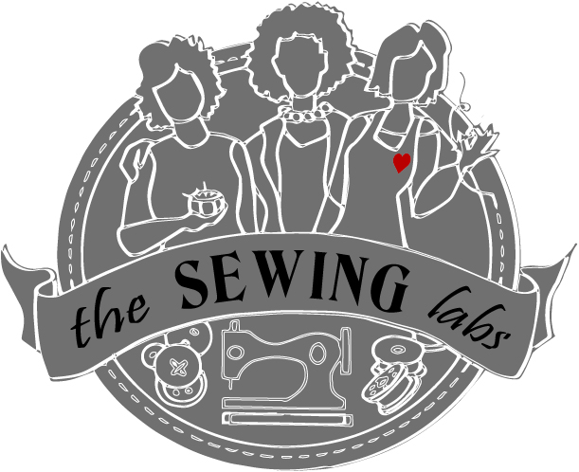
2017
Sunday | Monday | Tuesday | Wednesday | Thursday | Friday | Saturday
 |  |  | 1 | 2 | 3 | 4
Call or go on line to register for classes - 816-286-3097  Materials are included in class fees  All classes prefer advance registration |  |  |  | Closures 10-12  Open Sew 1-4  Closures 6-8 |  | Prayer Flags  9 am - 12
5 | 6 | 7 | 8 | 9 | 10 | 11
 |  |  |  | Textiles 10-12  Open Sew 1-4  Textiles 6-8pm | Just SEW-cial  11-7
12 | 13 | 14 | 15 | 16 | 17 | 18
 |  | Volunteer Committee – Quilting 6-8 pm |  | Open Sew  11-8 | St. Patrick’s Day
19 | 20 | 21 | 22 | 23 | 24 | 25
Patterns 10-12
Open Sew 1-4
Patterns 6-8
26 | 27 | 28 | 29 | 30 | 31 | 1
Unity of Independence  Workday |  |  |  | Community Mending Day  11-7
2  Thank you for your community involvement!  We accept donations; fabric, sewing machines, notions etc. & funding is always welcome |  |  |  | Limited Scholarships are available to cover some fees  Join us on Facebook Or Twitter

Open Sew –  Bring your sewing machine or rent one of ours ($10/ 2 hrs.) Use our tools and fabric stash to create. | Textiles  Getting to know fabrics, class covers an array of fabrics for sewing.  Class fee - $20 | Patterns  This class will teach you the tips to select a pattern and decide on the correct size for your body.  Class Fee - $20 | Closures – Zippers, Buttons & snaps learn different applications and uses for closures  Class Fee - $20 | Just SEW-cial!  Come hang out at The Sewing Labs. Sew or just socialize. Bring your friends - Enjoy coffee & treats  FREE | Prayer flags  Create a personal or home flag that inspires you to focus your energies on positive thoughts  Class Fee - $15

