February | #Inspire! #Create! #Thrive!  http/thesewinglabs.community
2017 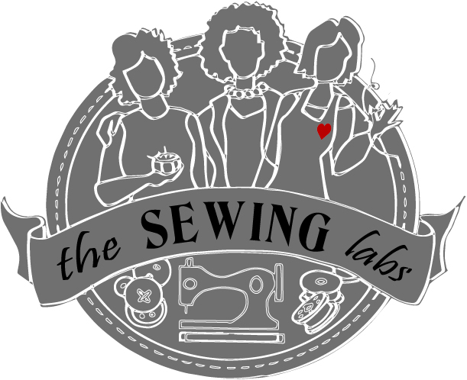 | 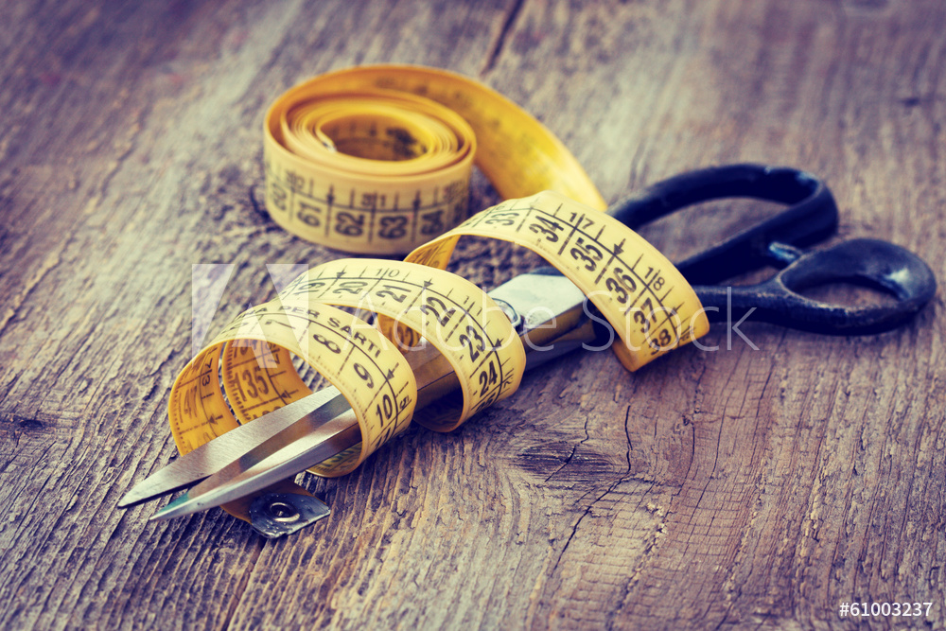
Sunday | Monday | Tuesday | Wednesday | Thursday | Friday | Saturday
 |  |  | 1 | 2 | 3 | 4
Call to register for classes  816-286-3097  All classes require advance registration |  |  |  | Open SEW  11 – 7 | Good Will Tour  10 am | WGC Craft Day  9-12
5 | 6 | 7 | 8 | 9 | 10 | 11
 |  |  |  | Tool Time 10-12  Open Sew 1-4  Closures 6-8pm | KC Works Together –  Open House  9-11
12 | 13 | 14 | 15 | 16 | 17 | 18
 |  | Valentine’s Day |  | Prayer Flags  10-12 & 6-8 | Just SEW-cial  11-7
19 | 20 | 21 | 22 | 23 | 24 | 25
 | President’s Day |  |  | Closures 10-12  Open Sew 1-4  Pattern Intro  6-8
26 | 27 | 28 | 1 | 2 | 3 | 4
 |  |  |  | Community Outreach – TBA Caring for others |  | Prayer Flags  9 am - 12
Thank you for your community involvement!  We accept donations; fabric, sewing machines, notions etc. & funding is always welcome |  |  |  | Limited Scholarships are available to cover some fees  Join us on Facebook Or Twitter

Open Sew –  Bring your sewing machine or rent one of ours ($10/ 2 hrs.) Use our tools and fabric stash to create. | WGC! Craft Day  A family gathering to craft & just have fun! We create several items for all ages.  Supply fee - $15 | Tool Time –  A lesson in tools & their uses. From cutting to measuring to marking –  Class Fee - $20 | Closures – Zippers, Buttons & snaps learn different applications and uses for closures  Class Fee - $20 | Just SEW-cial!  Come hang out at The Sewing Labs. Sew or just socialize. Bring your friends - Enjoy coffee & treats  FREE | Prayer flags  Create a personal or home flag that inspires you to focus your energies on positive thoughts  Class Fee - $15

