August | #Inspire! #Create! #Thrive!  http/thesewinglabs.community
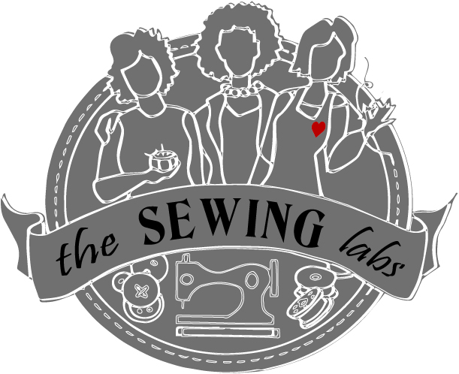  2017 | 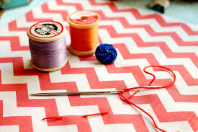
Sunday | Monday | Tuesday | Wednesday | Thursday | Friday | Saturday
 |  | 1 | 2 | 3 | 4 | 5
Call or go on line to register for classes – http//thesewinglabs.community or call 816-286-3097  Materials are included in most class fees  All classes prefer advance registration |  |  |  | Sewing Committee Mtg. 10-12
6 | 7 | 8 | 9 | 10 | 11 | 12
 |  | Carpenters Star Quilting – 6-8 pm 8 wks. Session 1 of 8 | Confidence Mtg.  1-2pm | Sewing Committee Mtg. 10-12  Open Sew 1-3  Wk. 4 -Garment Construction  6-8pm
13 | 14 | 15 | 16 | 17 | 18 | 19
 |  | Carpenters Star Quilting – 2-4 pm & 6-8 pm – 8 wks.  Session 2 of 8  Quilt Com Mtg. 430 - 530 |  | Pillows – Home Décor 10-12  Open Sew 1-3  Pillows – Home Décor 6-8
20 | 21 | 22 | 23 | 24 | 25 | 26
 |  | Carpenters Star Quilting – 2-4 pm & 6-8 pm – 8 wks.  Session 3 of 8 |  | Pillows – Home Décor 10-12  Open Sew 1-3  Pillows – Home Décor 6-8
2727 | 28 | 2929 | 30 | 3131 | 1 | 2
Unity of Independence  Workday |  | Community Projects 10-12  Carpenters Star Quilting – 2-4 pm & 6-8 pm – 8 wks.  Session 4 of 8 |  | Pillows – Home Décor 10-12  Sewing Machine Basics 1 - 3  Pillows – Home Décor 6-8
3 | 4 | 5 | 6  Open Sew – 1-3 Available Tuesday, Thursday & Friday | 7 | 8 | 9
See back for Class descriptions and pricing For Registration or more information - https://thesewinglab.community or email – operations@thesewinglabs.community or call/text – Linnca Stevens – Program Manager 816–286-3097
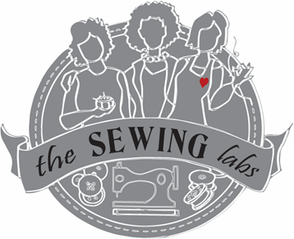
August 2017 Activities & Classes

Thank you for your community involvement!
We accept donations; fabric, sewing machines, notions etc. & funding is always welcome
** Limited Scholarships are available to cover some fees – Ask for scholarship application **
Open Sew – Bring your sewing machine or rent one of ours ($10 for 2 hours) Use our tools and stash to create your project. This is an open format with no instructions but, volunteers are available to help. Use the Open Sew time to practice your skills or to work on your own personal project. Class Fee is only to cover sewing machine rental = $10 for 2 hours

Sewing Machine Basics – This class is for first time sewing machine owners or someone who needs a refresher course. Learn the features of your sewing machine, how they work and what is their purpose. Learn sewing machine maintenance and proper selection of needles & thread. Class Fee = $20

Carpenters Star Quilt – This quilt is designed by Debbie Maddy of Calico Carriage. This is a great beginner to advanced project. You will learn how to make half-square triangles while making a quilt – you can choose a wall-hanging to full size. Materials can be used from our inventory or bring your own. Fabrics will be decided on at first class. Class is 8 sessions Class Fee = $80

Pillows – Home Décor – Learn to construct Home Décor accent pillows – you will learn how to put in a hidden zipper, a variety of edge techniques; corded, flange, ruffled and more. You will make cording yourself so you will always have a perfect match.
Class is 4 sessions. All Materials provided. Class Fee = $65

Garment Construction – In this class individuals make a garment of their choice – choose from our inventory of patterns and fabrics or bring your own. Sewing Machines and sergers are available. Class is 4 sessions Class Fee = $40

Community Projects – 4th Tuesday of the Month 10 – 12 &/or 4:30 – 5:30 We work on one of our community projects or Legacy Project – TBA – you will be provided with this quarters project selection, materials and pattern if needed. Community projects are an item that we are making to donate to local shelter or group such as; pillow cases, quilts, etc. You can work on them at the Labs during open sew or take home to work on. Then quarterly there is a Rally Day – to bring us together to gather the finished items for distribution. The Legacy Quilt – each person gets a quilt block to make in remembrance of the people who influenced their sewing. Please preregister for this workday.

Unity of Independence - Unity of Independence has partnered with The Sewing Labs to help us to build the kits for our classes. Monthly, the group gathers together to build the kits needed for the Sewing Labs. We enjoy fellowship while supporting each other. You are welcome to join us to build the kits after the morning services. Advance registration is suggested.

Confidence Meeting – This is a special meeting bringing together various organizations that support at-risk women in KC. Attendance by invitation only. Please feel free to inquire if you represent an agency that might be interested in partnerships with The Sewing Labs.

Committee Meeting – Become a partner at The Sewing Labs by joining a committee to develop & support programs. Whether you are interested in teaching or helping, your involvement is key for the success of our programs. Currently we have 2 committees that met each month – Quilting Committee meets the 2nd Tuesday from 430 – 6, Sewing Committee meets the 2nd Thursday from 10-12am. Please call/email ahead if planning to attend.
Coming in Fall/Holiday Season
- Hero Caps & Masks – just in time for Halloween – Adults & kid sizes – create your own “super-hero” cap and mask
- Field Trip to The Light Center in Baldwin City, KS – special craft – stay tuned!!
- Art Quilt – use the art of quilting and adding dimension thru beading, applique, charms, etc.
- Knitting & Crocheting – teachers wanted and classes forming soon!!
- Prayer flags – Back by popular demand
- Quick Christmas Gift items – create 4 different projects to use for your gift giving
- Pop-Up shops – support our “Makers” and “Sewist” by attending one of our POP-UP sales – TBA
- Commercial Sewing – learn on commercial machines for speed and accuracy and more
Thank you for your interest and support of The Sewing Labs – we need you!!!
- Volunteers – teachers and helpers so that we can offer more classes and train more women
- Teachers – in all subject in fabric mediums – if you have a craft – let us know.
- Donations – in-kind donations of fabric, notions, etc. are welcome
- Please consider a financial support to sponsor a student, a session or a series of classes.
Call or go on line to register for classes – http//thesewinglabs.community or call 816-286-3097
* Materials are included in most class fees * All classes prefer advance registration

