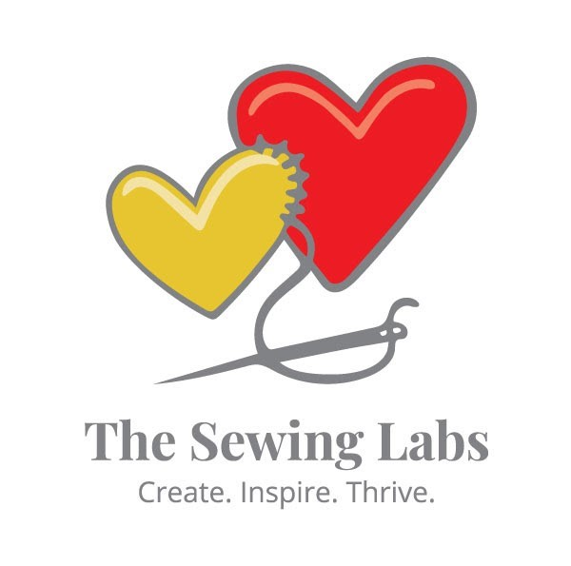
CARING FOR OUR COMMUNITY RULES & REQUIREMENTS FOR STAFF, VOLUNTEERS & PARTICIPANTS
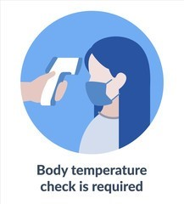
The Sewing Labs ("TSL") is committed to providing a safe and healthy workplace for all our staff, volunteers, and participants.

Health Monitoring and Policies for Individuals Exhibiting Signs and Symptoms of COVID-19

Health Monitoring: Staff, student volunteers and participants are encouraged to self-monitor for signs and symptoms of COVID-19 prior to coming to TSL and while at TSL. The following policies and procedures are being implemented to assess health status prior to entering TSL and for staff, volunteers and participants to report when they are sick or experiencing symptoms:

Check-in Prior to Entering TSL. All staff, volunteers and participants will be required to comply with the following steps prior to entering TSL:

  - Review the signs listing the symptoms of COVID-19 posted at all entrances to TSL and screen themselves to ensure they do not exhibit any of these symptoms each time they enter TSL. No one is permitted to enter the premises if they are experiencing any symptoms of COVID-19.

  - Arrive 10-15 minutes early and wait outside for admission to TSL. TSL will take measures to facilitate appropriate health precautions during the check-in process. If you arrive late, we will not be able to check you in. “NO DRIFTING IN.”

  - Read and sign the COVID-19 Rules and Requirements and TSL's COVID-19 Waiver Form (note, this will only be required the first time an individual enters TSL after TSL's re-opening).

  - Log-in with name, email, phone number, address and reason for visit (note, this will be required each day an individual enters TSL).

  - Have temperature taken (note, this will be required each day an individual enters TSL).

    - A temperature reading will be taken and recorded of everyone who wishes to enter our space. If your temperature is 100.3 or higher, you will not be allowed to enter TSL or participate in any TSL programs that day. You will be asked to wait 10 days, not had fever for at least 24 hours, and be symptom free before attempting to reenter TSL.

If Experiencing Symptoms or Exposed to COVID-19:

- Anyone who begins experiencing symptoms while at the facility must notify a member of administrative staff immediately and leave the facility immediately.

- If a staff member, volunteer, participant or a member of their household has a presumed or confirmed case of COVID-19, have been advised to self-quarantine by a healthcare provider, or are subject to a quarantine or isolation order, they must stay home and may not return to TSL until cleared to return to work by a healthcare provider and/or have met current CDC guidelines for return to work.

- Information about staff and volunteers' health status will be kept confidential, except for notification to the local health department.

Contact Tracing in Place.

- In the event that TSL learns that any of our staff, volunteers or participants have been diagnosed with COVID-19, close contacts (within six feet for 15 minutes or more) of those individuals will be contacted.

- TSL will use the sign in/out log for contact tracing information.

- Those who are traced to a confirmed or suspected case of COVID-19 will be restricted from returning to TSL until cleared to return by a healthcare provider and/or have met current CDC guidelines for returning or leaving self-isolation.

Policies for Facilitating a Healthy Workplace During COVID-19

Wearing a Non-medical Grade Face Mask. Everyone is required to wear a face mask upon entering & during any participation of TSL's space or “programs.” TSL has a limited number of fabric masks available.
Social Distancing Followed. As an added preventative measure, it is required that a distance of 6 feet or 2 meters be kept between all staff, volunteers and participants to reduce the spread of COVID-19 and other germs between each person. This distance must be maintained while moving through the space and while sitting at sewing stations during classes. Please observe this spacing when selecting a sewing station and seat yourself at every other machine.

Hand Washing, Sanitizer and Disinfectants. Everyone is required to follow basic hygiene measures at all times to reduce the spread of COVID-19 and other germs. More specifically:

  - Hand sanitizing station at the door.
  - Wash hands after entering TSL. Please use public restrooms for this.
  - Staff, volunteers and participants should repeat hand washing regularly (i.e. after classes, fresh air breaks, prior to any mealtimes and after using the bathroom).
  - Individuals must sanitize their sewing stations, equipment & tools before the beginning of a TSL program. Disinfectant wipes for sanitizing are in the industrial and domestic machine areas. Repeat this sanitizing process at the end of each session.
  - Disposable gloves are available, but not required, to operate sewing machines or other equipment.
  - Volunteers will check out a kit of tools and any equipment needed for their class.
  - To prevent cross contamination, NO sharing of tools or equipment is permitted.
  - Routine cleaning and regularly cleaning of high-touch areas are also being done by TSL.

Capacity Limitations. TSL will not immediately allow full capacity of participants into the facility. To maintain social distancing and follow city procedures we will be at 50% capacity. TSL staff will monitor capacity levels and react as needed if overcapacity.

Outside Drinks and Food. These items are allowed, but must follow these guidelines:
- Drinks are allowed in sewing stations if they are covered with a lid to prevent spilling and exposure—no pop cans.
- The kitchen area will be monitored to ensure compliance with these Rules and Requirements. Gloves are required for kitchen activities.
- Snacks can be eaten in the kitchen area.
- No community beverages or food.
- The microwave and refrigerator are limited to staff at this time.
- All foods must be sealed and marked with names with a preference to take home every night.

Children Under the Age of 16. Children 16 or under will not be allowed into TSL at this time. This decision will be re-evaluated every thirty (30) days or when public schools are back in session.

Teaching & Instruction Modifications. Teachers will restructure how they instruct to keep a 6-feet of distance between themselves and students if possible. Video instruction may be introduced for some classes to allow better instruction at a distance. Additionally, ironing stations will be available when possible or sanitation between users will be required.

Donations Processing. All donations will be held in quarantine within the donation center for 72 hours before processing. All donations will need to be dated & logged in upon receipt and be kept separate from other donations. Gloves are required to process donations, and hand washing must be done before beginning and after completing logging.

Restrooms. Restrooms are maintained by the landlord. However, these restrooms will be monitored by TSL staff to ensure adequate supplies are available. Please make TSL staff aware if restrooms need servicing.

Airflow. Airflow within the space will be routinely monitored and any issues will be immediately communicated to the landlord for resolution. Typically, our classes are 2-3 hours per session. The duration of the classes is not anticipated to change, but we will build in a fresh air break for any classes over two (2) hours. This will allow our staff, volunteers and participants to refresh themselves and re-wash their hands.

Communications and Training. These rules and requirements are being communicated by email to all staff and volunteers on [DATE]. Training will be available as needed. These Rules and Requirements are in place until further notice. It may be updated as necessary as this situation continues to evolve.

Thank you for following these guidelines. Please note that these Rules and Requirements do not constitute any guarantee by The Sewing Labs of full prevention of COVID-19 exposure at The Sewing Labs.

